

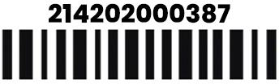
This report aims to provide an assessment of a used laptop. The purpose is to evaluate the condition of the device and provide potential buyers with detailed information regarding any cosmetic imperfections.

KEY HIGHLIGHTS
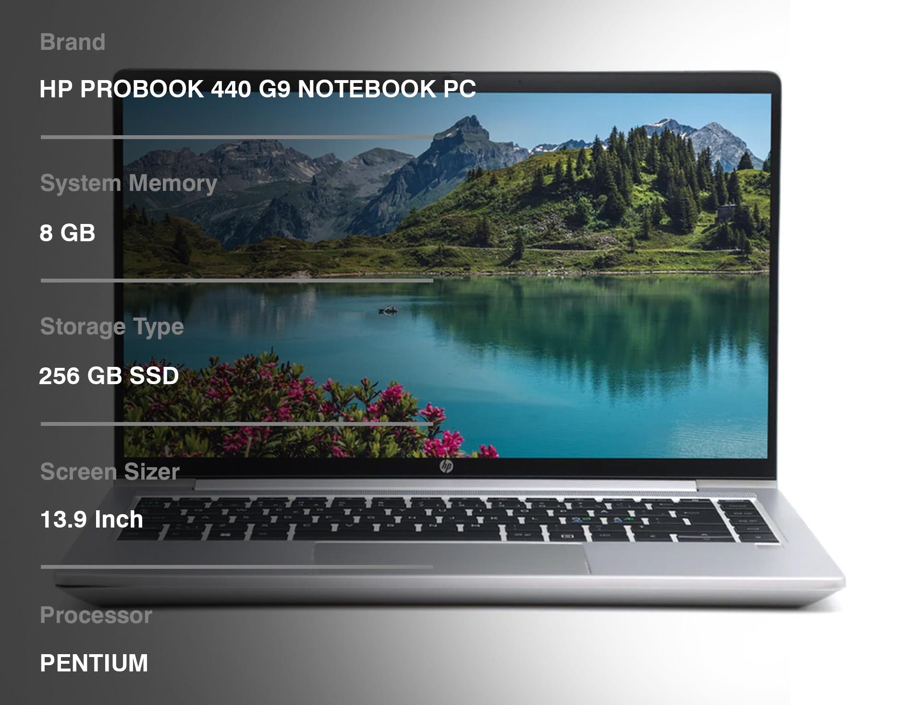

GENERAL EVALUATION
The HP Probook 440 G9 has been carefully inspected to assess its condition accurately, while the device is generally in
excellent condition we have identified some observations which are detailed below.
EXTERIOR EXAMINATION 
The top cover exhibits no scratches & the sides of the palm rest are also clean. However, slight wear and tear might be present.
Furthermore, the bottom panel remains clean and devoid of any scratches or marks, indicating minimal use or careful maintenance.
Overall, the rest of the device's exterior remains in excellent condition.

INTERNAL ASSESSMENT
The internal components of the laptop are in excellent condition. The keyboard functions perfectly, with all keys intact and showing no
signs of wear. Similarly, the touchpad operates smoothly and is free from any signs of wear or damage. The screen is immaculate, devoid of any
scratches, smudges, or blemishes, ensuring a clear and crisp display.
All ports and connectors have been thoroughly inspected and are in optimal working condition, guaranteeing reliable connectivity.
The battery's health 91% is also robust, maintaining its capacity effectively for prolonged usage.

CONCLUSION
The HP ProBook 440 G9 laptop is in excellent overall condition. Despite these minor imperfections, the device remains fully functional
and ready for use.

RECOMENDATIONS
We recommend the HP ProBook 440 G9 laptop for individuals who prioritize performance over minor cosmetic blemishes. With
its robust specifications and reliable performance, this laptop offers exceptional value for users needing a powerful computing solution.

DISCLAIMER
This inspection report is based on a comprehensive visual examination conducted by our certified technicians. While every effort has been made to provide an accurate assessment, individual perspectives can vary. Henc,e prospective buyers are encouraged to conduct their own inspection or request additional information to ensure complete satisfaction with their purchase decision.

