INSPECTION REPORT 
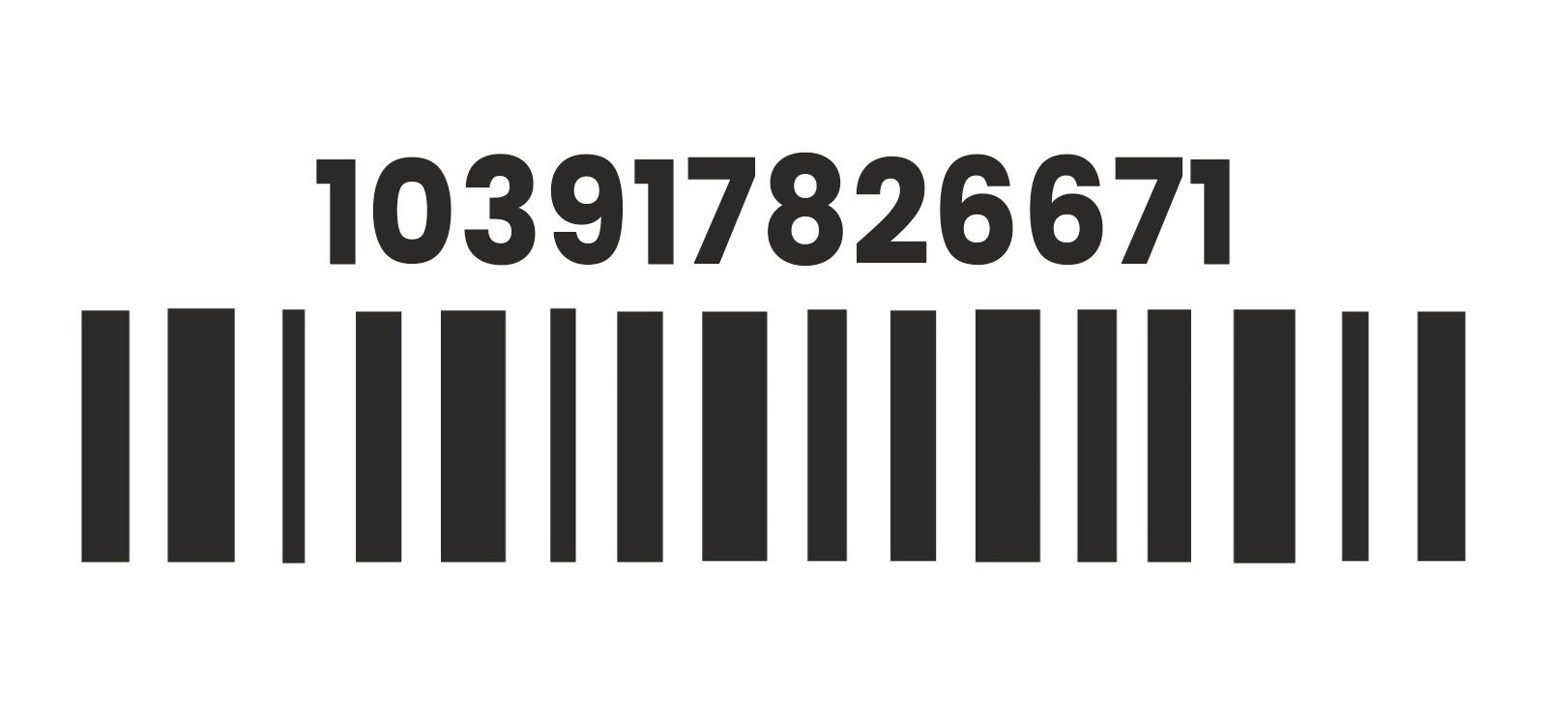 104792919008

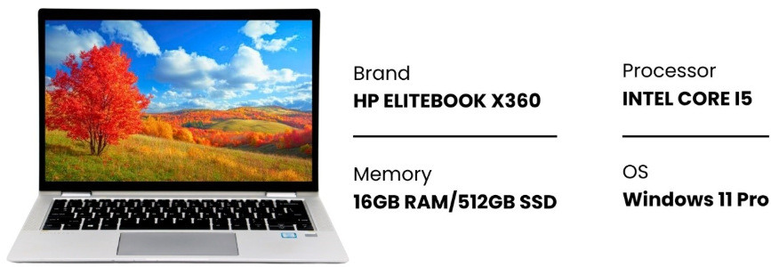




Fully Functional Battery 100% 3-Month Warranty

COSMETIC SUMMARY
Display ✓ Scratch Free Top Cover ⚠️ Minor wear
Keyboard ✓ Clean Palm Rest ✓ Clean
Bottom Cover ⚠️ Major Wear

DEVICE CONDITION PHOTOS

Image 1:
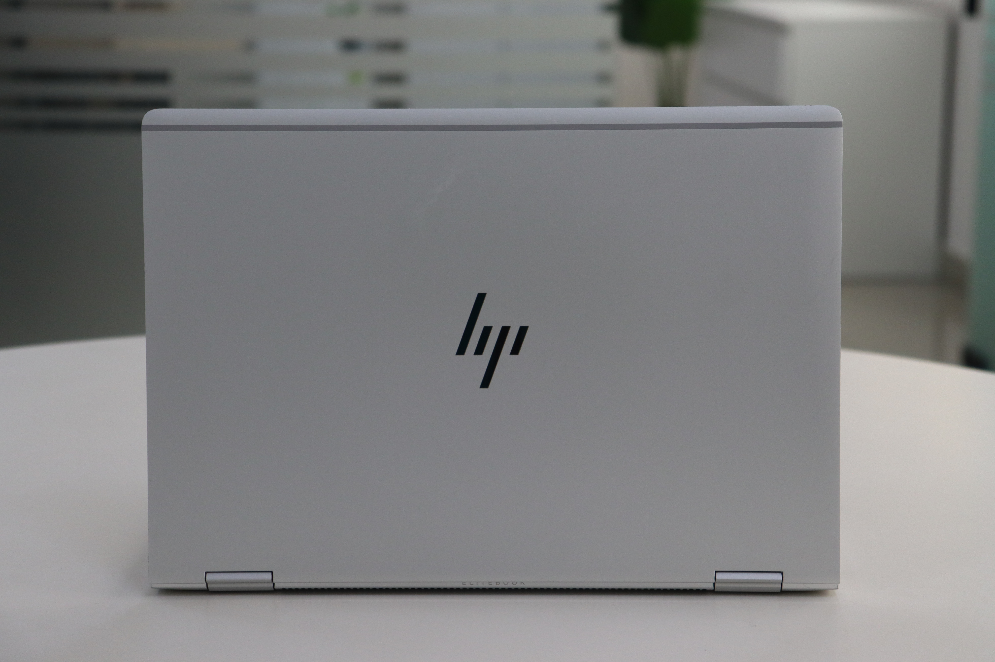

Image 2:
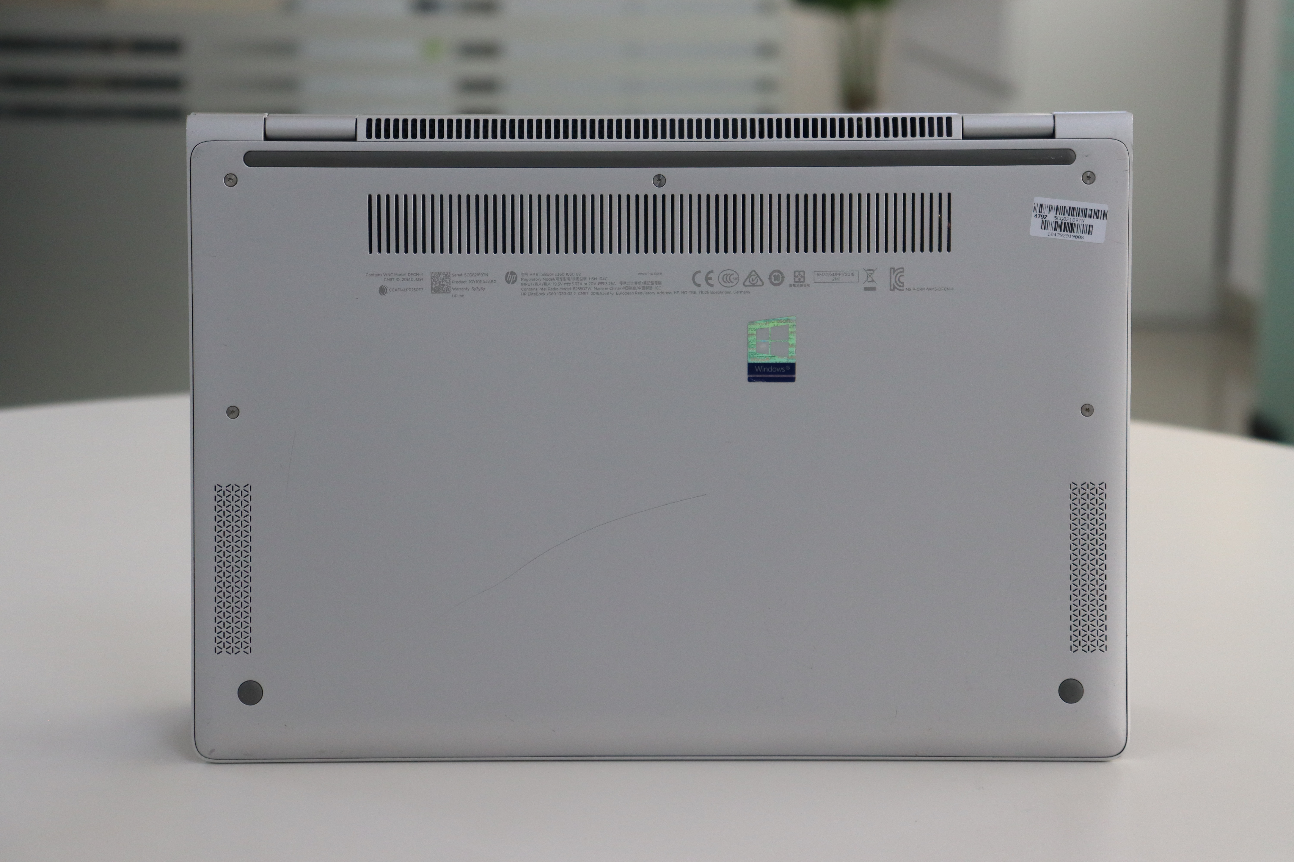

TECHNICIAN OBSERVATIONS

- The top cover has minor scratches.
- The keyboard and the sides of the palm rest are clean.
- Major scratches, on the back cover.




Genuine Windows Charger Included R Ready to Use Professionally Tested

INSPECTION DISCLAIMER

Cosmetic assessment reflects appearance only and does not impact device performance.

